T.L.E Reviewer
Fundamentals of Food Service
Categories of Food Service:
- Commercial Food Service – Operates mainly for profit. The industry includes the businesses, institutions, and companies which prepare meals outside the home. It includes restaurants, grocery stores, school and hospital cafeterias, catering operations, and many other formats.
- Fine Dining – This aims to provide the best cuisine, service, and atmosphere all in one with offerings come with a high price for customers. But they also give culinary professionals an opportunity to be creative with top-of-the-line ingredients.
- Casual or Family Style – Offers either a highly specialized or a broad range of menus where entrees are moderately priced and meals are served with modest formal arrangements complete with table implements.
- Cruise Line – Provide a unique experience for customers coming from different lands that prepare many different dishes that cater to many different cultures that are also a good opportunity for chefs and skilled cooks who travel.
- Food Hall – This comprises a diverse set of restaurants with limited menus that feature local and international cuisine and fresh healthy dishes that is a good place to test new recipes, revise existing ones, or try a new approach in food service stalls.
- Food Trucks – These are mobile eateries that can stand alone or join a line of food trucks, or the smaller version called food carts. Which are found in markets, plazas and commercial areas in a community, town, or city.
- Welfare Food Service – Caters to a particular group of people like employees in companies or industries, or students in schools, and patients in hospitals and health care establishments. Canteens or cafeterias in these establishments operate primarily for service and secondarily for profit.

Restaurant Areas:
- Front of the House (FOH) – The area where employees interact directly with customers. It focuses on providing excellent customer service and creating a positive dining experience. Common FOH staff include hosts/hostesses, servers, cashiers, bartenders, and dining supervisors. Common FOH areas include the dining room, waiting area, reception area, cashier station, and beverage station.
Areas:  - Reception Area  - Waiting Area  - Dining Area  - Cashier Station  - Beverage Station | Personnel:  - Host or Hostess  - Server, Waiter, or Waitress  - Cashier  - Bartender  - Dining Supervisor
- Back of the House (BOH) – The area not accessible to customers where food preparation, cooking, cleaning, and storage take place. Common BOH staff include chefs, cooks, kitchen assistants, dishwashers, and stock clerks. Common BOH areas include the kitchen, food preparation area, storage room, pantry, dishwashing area, and receiving area.
Areas:  - Kitchen  - Food Preparation Area  - Pantry  - Storage Room  - Receiving Area  - Dishwashing Area | Personnel:  - Executive Chef  - Sous Chef  - Line Cook  - Kitchen Assistance  - Dishwasher  - Stock Clerk

Communication and Interpersonal Skills:
- Communication – Act of imparting or relaying messages or information to one more person to transfer information, ideas, and emotions between a sender and a recipient.
- One-way Communication – A linear process where a sender transmits a message to a receiver without expecting or allowing a response.
- Two-way Communication – Is an interactive loop where both parties exchange messages and provide feedback, ensuring the message is understood.
- Direct Communication – Verbal communication done by talking directly to the employees concerned or those who will be affected by the decision.
- Indirect Communication – Done mostly in writing that can be through memos and directed to employees concerned. In memos the employees may or may not be required to sign the document to show that they have received and read the memos.
- Intrapersonal Communication – Communication within yourself involving self-talk, reflection, thinking, and decision-making. It helps with self-awareness, problem-solving, and personal growth.
- Interpersonal Communication – The exchange of information, ideas, and feelings between two or more people. It is used to build relationships, resolve conflicts, and promote effective communication.
- Horizontal Communication – The exchange of information between individuals or departments at the same organizational level. It improves coordination, teamwork, collaboration, and problem-solving.
- Vertical Communication – The exchange of information between different levels of an organization. It can be downward communication (from managers to employees) to provide instructions, policies, or feedback, or upward communication (from employees to managers) to share reports, suggestions, or concerns.
- Positive Reinforcement – A method of encouraging desired behavior by giving a reward or positive consequence immediately after the behavior occurs, making it more likely to happen again.
- Tangible Reinforcement – A type of positive reinforcement that uses physical or material rewards, such as money, certificates, trophies, gift cards, or prizes, to encourage desired behavior.
- Intangible Reinforcement – A type of positive reinforcement that uses non-material rewards, such as praise, recognition, encouragement, privileges, or appreciation, to motivate and reinforce desired behavior.

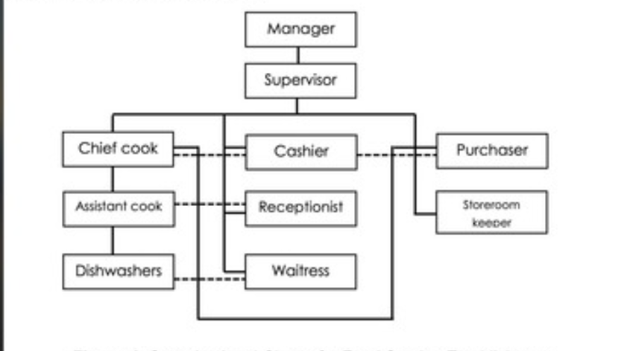

Duties and Responsibilities of Food Personnel:
- Food Service Manager – Oversees the entire operation of the food establishment, ensuring cleanliness, quality food, efficient service, and cost control. Responsible for planning daily operations, creating menus, supervising food preparation, maintaining quality and safety, planning special menus and promotions, monitoring food service trends, coordinating with suppliers, and preparing business reports.
- Assistant Manager/Supervisor – Assists the Food Service Manager in directing, supervising, and controlling daily operations. Takes charge when the manager is absent and monitors service during peak hours to ensure efficient operations.
- Chief Cook – Leads the kitchen operations by planning, preparing, and cooking meals. Ensures food quality, identifies required kitchen items, guides cooks, and checks that food meets customer requirements.
- Assistant Cook – Assists the Chief Cook in preparing and cooking food. Must be competent, knowledgeable, patient, resourceful, and physically able to handle long working hours.
- Purchaser – Buys materials, ingredients, and supplies at the best quality and lowest possible price. Monitors market conditions, coordinates with the storeroom keeper, checks incoming deliveries for quality, weight, and specifications, and rejects items that do not meet standards.
- Storeroom Keeper – Organizes and stores materials and supplies, verifies specifications, performs inventory checks, and prepares daily reports on incoming and outgoing stocks.
- Counter Attendant and Service Crew – Receives customer orders, serves food, clears tables, and ensures cleanliness of service wares. Must have good communication skills, professionalism, knowledge of the menu, and provide excellent customer service.
- Cashier – Handles cash transactions, operates the cash register, and prepares daily, weekly, and monthly financial reports.
- Other Employees – Includes dishwashers and sanitation personnel responsible for cleaning and maintaining hygiene. They should be properly trained, skilled, and have a positive work attitude.

Work Hazards and Risks:
- Work Hazards – Any condition, situation, or practice in an occupational setting with the potential to cause harm, injury, or illness that can come from different sources in the workplace.
- Physical Hazards – Hazards caused by unsafe working conditions, poor lighting, poor ventilation, insufficient facilities, faulty or inefficient equipment, or improper work practices (e.g., incorrect use of knives) that may result in accidents or injuries.
- Biological Hazards – Hazards caused by disease-causing microorganisms such as bacteria, viruses, parasites, and fungi, often due to infected workers or poor personal hygiene, which can contaminate food, equipment, and other workers.
- Ergonomic Hazards – Hazards caused by poor posture or repetitive tasks such as standing, bending, pushing, lifting, or carrying for long periods, leading to body stress, muscle pain, back injuries, and numbness.
- Psychological Hazards – Hazards caused by excessive work-related stress, resulting in mental and emotional strain, anxiety, depression, and loss of focus at work.
- Chemical Hazards – Hazards caused by exposure to chemicals, including cleaning disinfectants, fumes, and cooking smoke, which may be harmful to health if not handled properly.
- Strategies in Identifying Hazards and Risks:
- Observe your workplace.
- Interview coworkers about any complains.
- Look into past records of work-related injuries.
- Gather other information about the workplace.
- Controlling Hazards and Risks in the Workplace:
- Eliminating or removing completely the cause of the hazard.
- Substituting hazardous materials with less hazardous ones.
- Engineering control.
- Administrative control.
- Wearing personal protective equipment.

Safety Practices in the Kitchen:
- Keeping Oneself Clean – Washing hands thoroughly, keeping fingernails short and clean, always wearing you personal; protective equipment (PPE), wearing a mask, and removing all accessories.
- Keeping Tools and Equipment Clean – Following the correct procedure in washing, drying, and storing kitchen tools and equipment.
- Keeping the Food Clean – Never handling food with wounds, cuts and infections; always wearing gloves, refrigerating food, washing fruits and vegetables and checking their respective containers, and check the label of foods.
- Keeping the Workplace Clean – Not doing any personal hygiene in the workplace, not eating, smoking, or spitting in the workplace; Not sitting on any equipment, keeping the surrounding areas free from dirt and keeping them organized.

Safety Regulations:
- Clean Air Act of 1999 (Republic Act No. 8729) – Sets a comprehensive air quality management policy and program, which aims to provide and maintain healthy air for all citizens of the country.
- Solid Waste Management Program – Government program designed to instill awareness in people on how to manage their household wastes by implementing waste management practices, which is the collection, transportation, and processing of waste.
- Solid Wastes – Waste in dried form and consist of residential, household, and domestic wastes, such as empty containers made of plastic, glass, paper, scrap iron, and other trash.
- Liquid Wastes – Waste in liquid form. Includes human waste, flood water, and industrial wastewater.
- Hazardous - Unsafe dangerous substances that affect the health of the people. These are substances that are disposed of industries, agriculture, and business establishments.
- Non-Hazardous – Safe substances used commercially, industries, and common products.
- Process Flow of Waste Management:
- Reduce – Minimize the amount of waste.
- Reuse – Use discarded materials again.
- Recycle – Transform discarded materials into something new.
- Recover – Generate energy from waste.
- Dispose – Throw waste in landfill.
- Electrical and Fire Safety Code – This code contains precautions on how to prevent or reduce fire occurrence at home and in the workplace that may result in death, injury, and loss of properties.
- Contingency Measures and Procedure – A written emergency plan of action to be taken to reduce hazards and consequences from fires, earthquakes, explosions, and chemical wastes that may pollute the air, soil, and water.

